# CS 255 System Design Document Template

This template lays out all the different sections that you need to complete for Project Two. Each section has guidance to prompt your thinking. You will need to continually reference the interview transcript as you work to make sure that you are addressing your client’s needs. There is no required length for the final document. Instead the goal is to complete each section based on what your client’s needs are. Remove this note when you are finished, and replace all bracketed text with the relevant information.

## UML Diagrams

### UML Use Case Diagram

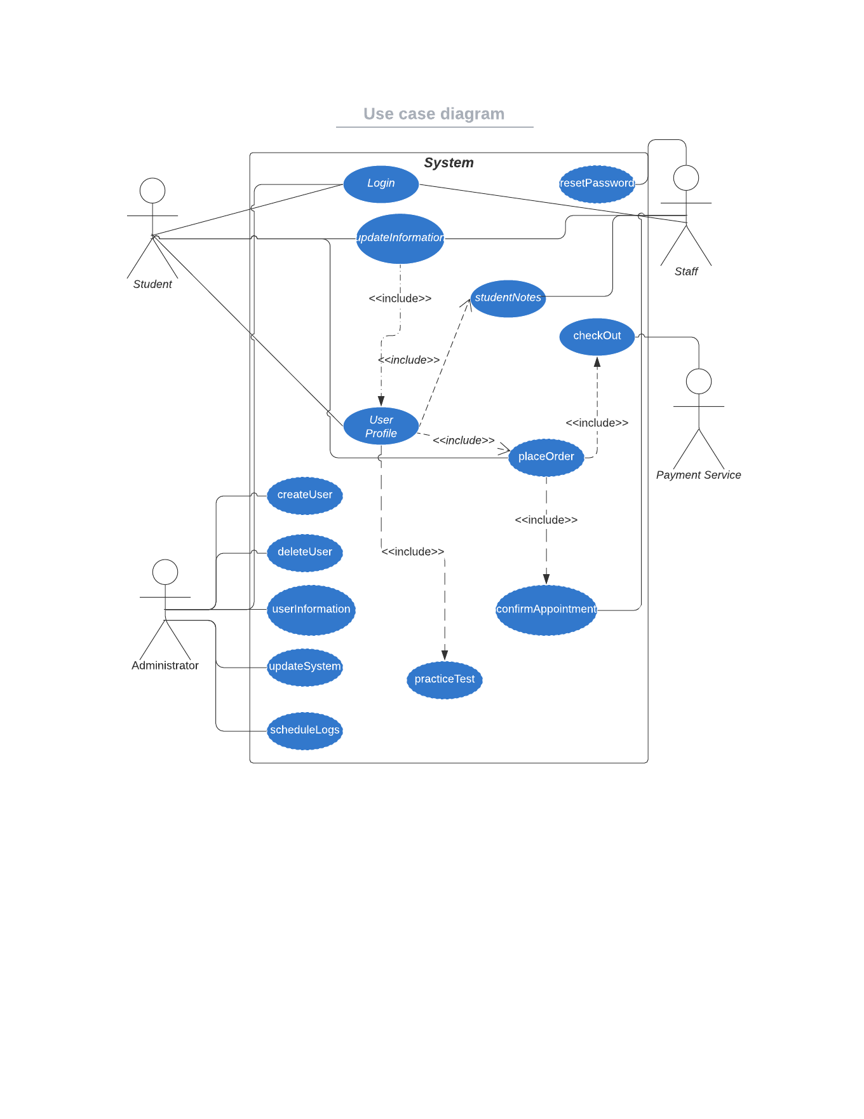

### UML Activity Diagrams

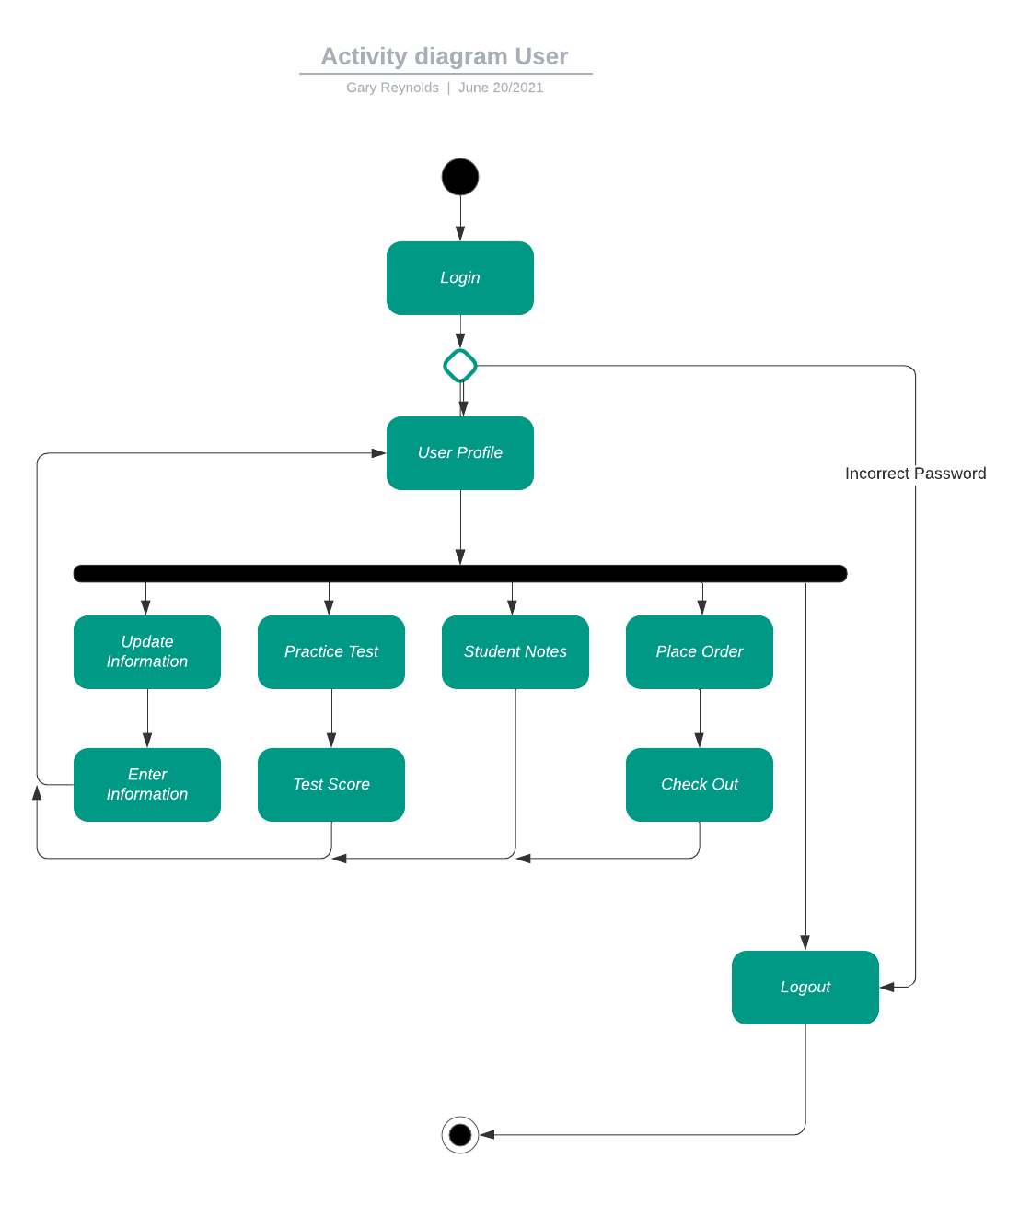

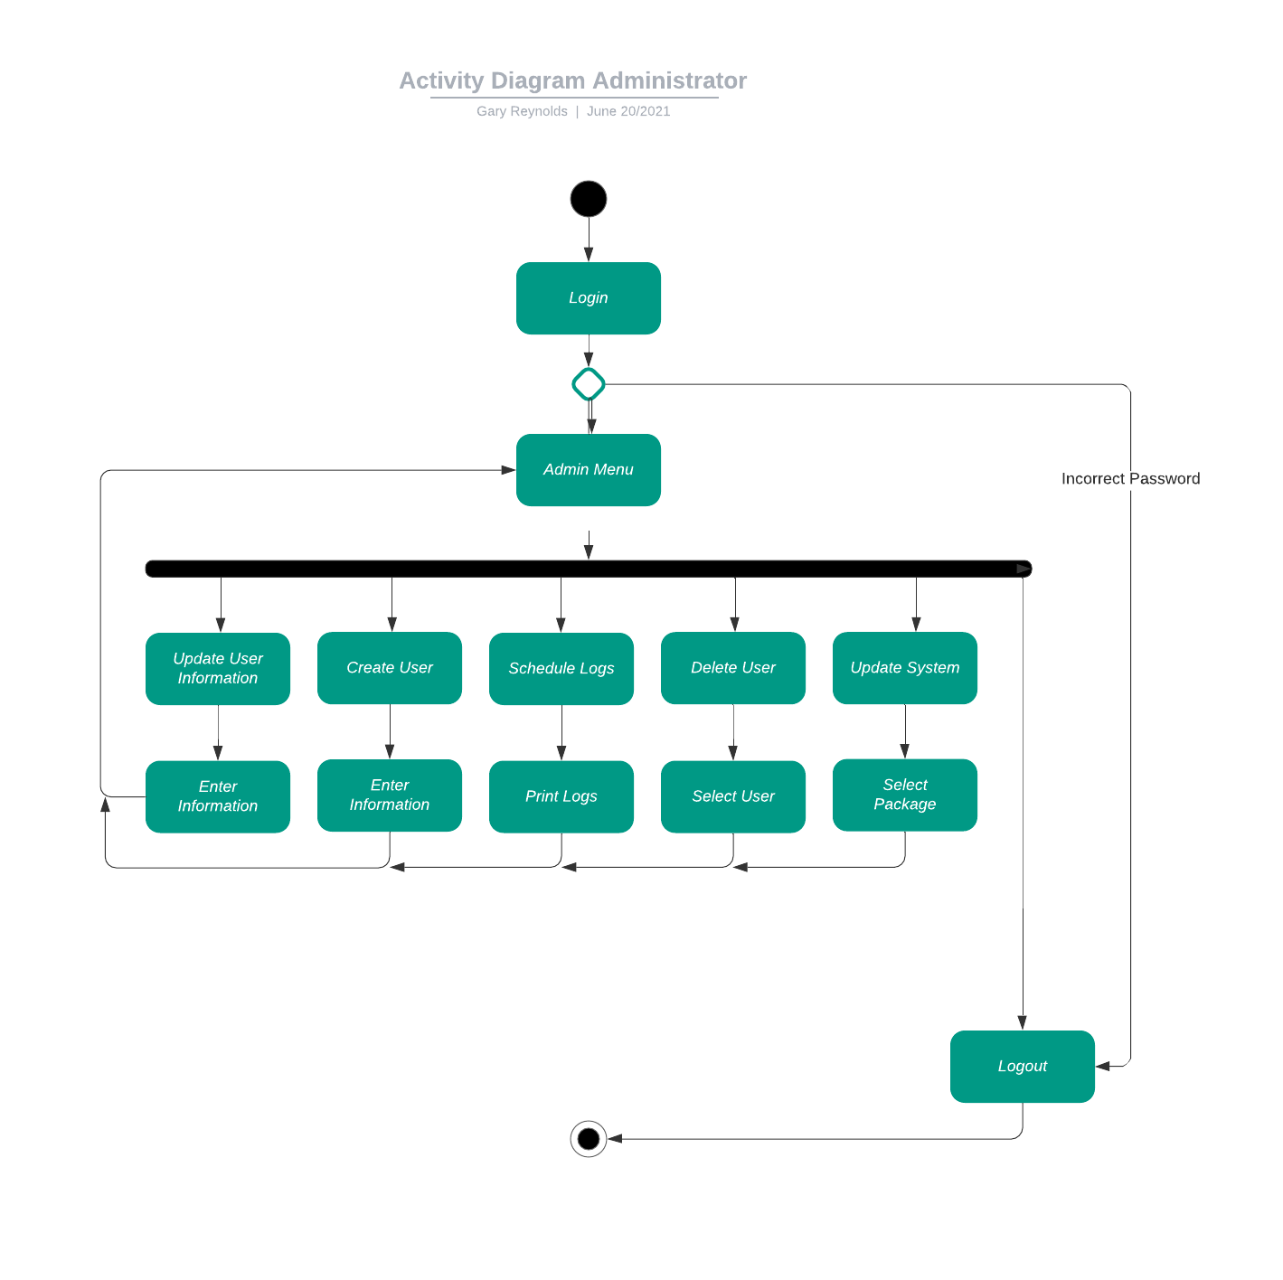

### UML Sequence Diagram

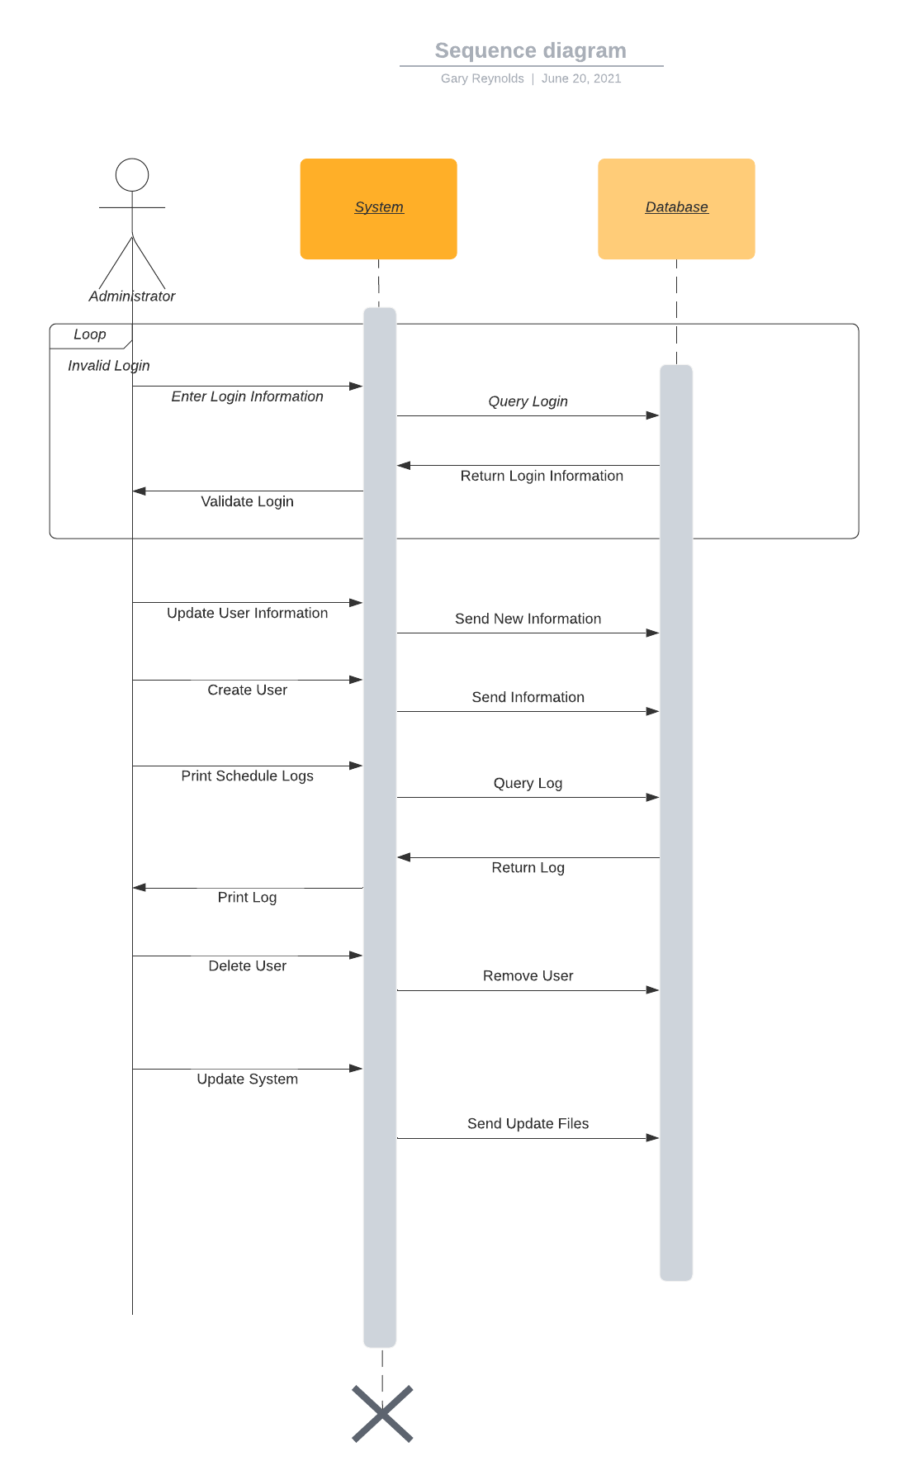

### UML Class Diagram

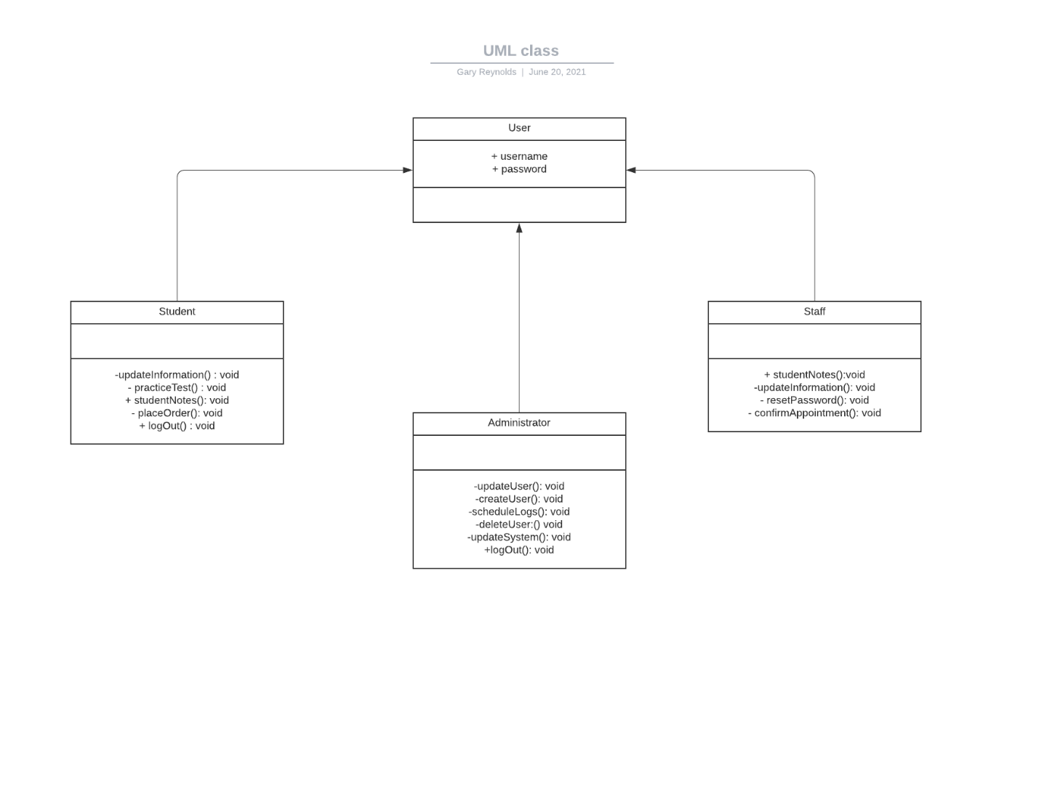

## Technical Requirements

The technical requirements are fairly minimal in this system. We will need a database, most likely cloud-based to store information in the system. For security we will need encryption on data being sent in the system and access that follows the principal of least privilege. Other technical requirements would be stable internet connection and a device capable of accessing the internet (Mac, PC, mobile devices).